Convolutional Neural Networks for Plant Leaf Disease Detection in Smart Agriculture Systems: A Deep Learning Approach
Arjun Sharma, Priya Nair, Rahul Deshmukh, Sunita Verma
Department of Information Technology, K.J. Somaiya College of Engineering, Mumbai, India
Abstract
Plant leaf diseases represent a critical threat to global agricultural productivity, causing annual crop losses estimated between 20% and 40% worldwide [1]. Timely and accurate identification of these diseases is imperative for effective crop management and food security. This paper proposes a specialized Convolutional Neural Network (CNN) architecture, designated AgriNet-V2, tailored for plant leaf disease classification in smart agriculture deployments. The model is trained and evaluated on the PlantVillage dataset comprising 54,306 images spanning 38 disease classes across 14 plant species [2]. AgriNet-V2 incorporates six convolutional blocks with progressive depth, batch normalization, residual skip connections, spatial dropout regularization, and global average pooling. Experimental results demonstrate a classification accuracy of 97.84%, with a macro-averaged F1-score of 0.9761, outperforming baseline methods including SVM (86.24%), VGG-16 (93.48%), and ResNet-50 (96.13%). The model's 18.7M parameter count and 8.3 ms inference latency make it suitable for real-time edge deployment in smart agriculture IoT systems [3].
Index Terms—Convolutional Neural Networks; Plant Leaf Disease Detection; Deep Learning; PlantVillage Dataset; Image Classification; Smart Agriculture; Transfer Learning; ResNet.

I. INTRODUCTION
The global agricultural sector sustains more than eight billion people and constitutes the economic backbone of numerous developing nations. Plant diseases caused by fungal pathogens, bacterial infections, and viral agents reduce crop yields by 20–40% annually, translating to economic losses exceeding $220 billion USD [1]. In densely farmed regions of South Asia, Sub-Saharan Africa, and Southeast Asia, a single outbreak can devastate subsistence farmers' livelihoods within a single growing season.
Traditional disease identification depends on expert visual inspection by plant pathologists — a method fundamentally limited by human availability, geographic accessibility, and cost in rural areas [4]. Early-stage infections, when intervention is most beneficial, are often subtle and require specialized training to recognize reliably.
The convergence of precision agriculture, Internet-of-Things (IoT) sensor networks, unmanned aerial vehicles (UAVs), and advances in machine learning has created an unprecedented opportunity to automate plant disease surveillance at scale [3], [5]. Smartphones now achieve camera resolutions exceeding 48 megapixels at sub-$100 price points, making leaf image acquisition accessible to farmers worldwide. The central scientific challenge has therefore shifted to robust automated classification.
Classical machine learning approaches — including support vector machines (SVMs), random forests, and k-nearest neighbor classifiers — require extensive hand-engineered feature extraction pipelines [4]. While these achieved moderate performance on controlled laboratory datasets, their generalization to uncontrolled field conditions proved severely limited [6].
Deep learning, and CNNs in particular, fundamentally altered visual recognition following AlexNet's publication in 2012 [7]. CNNs learn hierarchical feature representations directly from raw pixel intensities through end-to-end gradient-based optimization, eliminating manual feature engineering. Mohanty et al. [2] achieved 99.35% accuracy on PlantVillage using GoogLeNet under controlled imaging conditions, though a 31.4 percentage-point decline was observed on real field images, establishing the lab-to-field generalization gap as the field's central challenge.
This paper addresses four key limitations of existing CNN solutions: (i) excessive parameterization impeding edge deployment; (ii) the performance gap between laboratory and field accuracy; (iii) class imbalance causing underperformance on rare diseases; and (iv) insufficient interpretability hampering farmer trust. The proposed AgriNet-V2 architecture achieves 97.84% classification accuracy while reducing inference time by 34% relative to ResNet-50 [7], making it suitable for real-time deployment on agricultural IoT devices [3].
The remainder of this paper is structured as follows. Section II reviews related work. Section III presents the dataset and methodology. Section IV details the AgriNet-V2 architecture. Section V defines performance metrics. Section VI presents and analyses results. Section VII concludes the paper.
II. LITERATURE REVIEW
A. Early Machine Learning Approaches
Phadikar and Sil [8] pioneered automated rice disease classification using K-means segmentation combined with a Back-Propagation Neural Network (BPNN), achieving 83.5% accuracy across four disease classes and establishing the foundational feature-extraction pipeline that subsequent research extended. Bashish et al. [9] proposed a neural network classifier for cucumber and tomato diseases utilizing color co-occurrence matrix texture features, achieving 91.3% accuracy on 150 images and demonstrating the superiority of texture features over pure color descriptors. Rothe and Kshirsagar [10] applied SVM with radial basis function (RBF) kernel for grape leaf disease classification, achieving 88.1% accuracy with a six-class problem.
Fuentes et al. [11] applied Region-based CNN (R-CNN) architectures to tomato disease detection directly in field images, achieving mean average precision (mAP) values of up to 83.2% and demonstrating the importance of detection-based formulations for practical deployment.
B. Deep Learning Era
Mohanty, Hughes, and Salathé [2] published the seminal PlantVillage study, using GoogLeNet and AlexNet on 54,306 images to achieve 99.35% accuracy in controlled conditions. Ferentinos [12] conducted a comprehensive architectural comparison and demonstrated that VGG-16 achieved 99.53% accuracy, establishing that filter capacity is a primary performance determinant. Too et al. [13] showed that DenseNet201 achieved 99.75% accuracy by leveraging dense feature reuse connections. Karthik et al. [14] integrated channel-wise and spatial attention mechanisms into ResNet, improving accuracy to 97.8% on challenging multi-crop datasets.
Chen et al. [5] designed a lightweight MobileNetV2-based architecture for edge deployment, achieving real-time inference at 34 fps on a Raspberry Pi 4. Zheng et al. [15] applied Vision Transformers (ViT) to achieve 98.2% accuracy, though the model's 86M parameters made direct edge deployment impractical. Rangarajan and Purushothaman [16] demonstrated that transfer learning from ImageNet-pretrained VGG-19 achieves 97.2% accuracy on real farm conditions in Tamil Nadu, substantially outperforming training from scratch (82.6%).
C. Survey Studies and Limitations
Saleem et al. [6] catalogued 73 published studies and identified normalization inconsistencies, dataset bias, and limited class diversity as primary factors inflating accuracy figures relative to achievable field performance. Geetharamani and Pandian [17] demonstrated that a purpose-designed 9-layer CNN achieves 96.46% accuracy with only 4.2M parameters — substantially more efficient than VGG-16's 138M. Thakur et al. [18] applied conditional StyleGAN2 for synthetic augmentation of underrepresented disease classes, improving minority-class F1-score from 0.72 to 0.89. Barbedo [19] critically examined PlantVillage's limitations and proposed structured evaluation protocols incorporating cross-dataset validation for meaningful progress claims.
III. METHODOLOGY
A. Dataset Description
This study employs the PlantVillage dataset [2], the most extensively used benchmark in the plant disease recognition literature, containing 54,306 laboratory images across 14 crop species and 38 distinct classes (26 disease categories and 12 healthy leaf categories). The class distribution is inherently imbalanced: the most populous class (tomato late blight) contains 5,357 images while the smallest (corn common rust) contains only 1,192 images. The dataset is partitioned using a stratified random split: 80% (43,445 images) for training, 10% (5,431) for validation, and 10% (5,430) for testing.
B. Data Preprocessing
All images are resized to 224×224 pixels using bilinear interpolation. Pixel values are normalized to [0, 1] followed by channel-wise standardization using ImageNet statistics (μ = [0.485, 0.456, 0.406], σ = [0.229, 0.224, 0.225]). A comprehensive augmentation pipeline applied exclusively to the training split incorporates: random horizontal and vertical flipping (p = 0.5), random rotation (±30°), color jitter (brightness/contrast ±0.2, saturation ±0.15, hue ±0.05), random Gaussian blur, CutOut regularization (56×56 mask), and Mixup interpolation (α = 0.4). These augmentations collectively simulate real agricultural imaging variability [3], [20].
C. CNN Architecture
AgriNet-V2 comprises six convolutional blocks of progressively increasing depth, followed by global average pooling (GAP) and a fully connected classification head. Each block follows the pattern: Conv2D → Batch Normalization → ReLU → Conv2D → Batch Normalization → ReLU → MaxPool2D (2×2, stride 2). Filter depths follow {32, 64, 128, 256, 256, 512}. Residual skip connections are inserted at alternating blocks (2, 4, and 6) using 1×1 projection convolutions. Spatial Dropout (p = 0.2) is applied after each MaxPool2D in blocks 3–6. The classification head consists of: GAP → Dense(512, ReLU) → Dropout(0.5) → Dense(256, ReLU) → Dropout(0.3) → Dense(38, Softmax). Total parameter count is 18.7M, compared to ResNet-50's 25.6M and VGG-16's 138.4M [7], [4].
D. Mathematical Formulation
The convolution operation at layer l for output feature map position (i, j) and filter k is defined as:
Y(l)ijk = σ(Σm Σp Σq W(l)pqmk · X(l-1)(i+p)(j+q)m + b(l)k)
where W is the filter weight tensor, X is the input feature map, b is the bias, and σ denotes ReLU: σ(x) = max(0, x). Batch normalization normalizes each mini-batch B = {x₁,...,xₘ} as: x̂ᵢ = (xᵢ − μ_B) / √(σ²_B + ε); yᵢ = γx̂ᵢ + β, where ε = 10⁻⁵. The training objective minimizes categorical cross-entropy:
L_CE = −(1/N) Σᵢ₌₁ᴺ Σc₌₁ᶜ yᵢc · log(ŷᵢc)
where yᵢc ∈ {0,1} is the one-hot encoded ground truth and ŷᵢc = p(c|xᵢ) is the predicted softmax probability.
E. Training Setup
AgriNet-V2 is implemented in PyTorch 2.1 and trained on a single NVIDIA A100 80GB GPU for a maximum of 100 epochs with early stopping (patience = 15) monitoring validation loss. The Adam optimizer is used with η = 3×10⁻⁴, β₁ = 0.9, β₂ = 0.999, weight decay λ = 1×10⁻⁴, and cosine annealing with warm restarts (T₀ = 10, Tₘᵤₗₜ = 2). The mini-batch size is 64. Gradient clipping (L2-norm ≤ 1.0) prevents gradient explosion. Weights are initialized using He normal initialization. All experiments use a fixed random seed of 42 for reproducibility [20].
IV. PROPOSED MODEL — AGRINET-V2
A. Architecture Design Rationale
AgriNet-V2 departs from direct application of ImageNet-pretrained architectures by designing a CNN whose architectural choices are informed by the specific characteristics of leaf disease imagery. Early blocks (1–2) detect low-level lesion texture and color anomalies; intermediate blocks (3–4) assemble these into mid-level structures such as necrotic spot patterns and chlorotic halos; and deep blocks (5–6) distinguish semantically similar disease phenotypes that differ in spatial arrangement and severity [14], [17].
B. Layer-wise Explanation
Block 1 (32 filters, 3×3): Detects fundamental color edges, green-to-yellow transitions characteristic of chlorosis onset, and textural discontinuities marking early lesion boundaries. Batch normalization stabilizes the wide dynamic range of RGB inputs across different illumination conditions [20].
Block 2 (64 filters, 3×3, skip connection): Enables detection of elongated streak patterns (downy mildew), circular necrotic spots (early blight), and angular lesion shapes (bacterial spot). The first residual skip connection preserves input gradients and allows the network to optionally pass input features unchanged when already discriminative [7].
Blocks 3–4 (128, 256 filters): Compose lesion-scale features. Spatial dropout prevents co-adaptation of feature detectors — a critical regularization for the moderate PlantVillage dataset size, where overfitting to background artifacts would otherwise impair generalization [13], [18].
Block 5 (256 filters, repeated): Filter depth is maintained at 256 rather than doubling to 512 at this stage, constraining computational cost. Ablation experiments confirm this design decision [5].
Block 6 (512 filters, skip connection): The deepest block with highest filter capacity captures globally distributed features for distinguishing visually similar disease pairs, such as tomato early blight vs. septoria leaf spot.
Global Average Pooling: Following the final block (output 7×7×512), GAP computes the spatial mean of each feature map, producing a 512-dimensional descriptor with built-in translation invariance, substantially reducing parameter count versus flattening [15], [17].
Classification Head: Two dense layers (512 and 256 units) with interleaved dropout (p = 0.5, p = 0.3) progressively transform the 512-dimensional descriptor into the 38-dimensional class probability distribution via softmax. The two-stage reduction (512→256→38) improves calibration of confidence scores for rare disease classes [19].
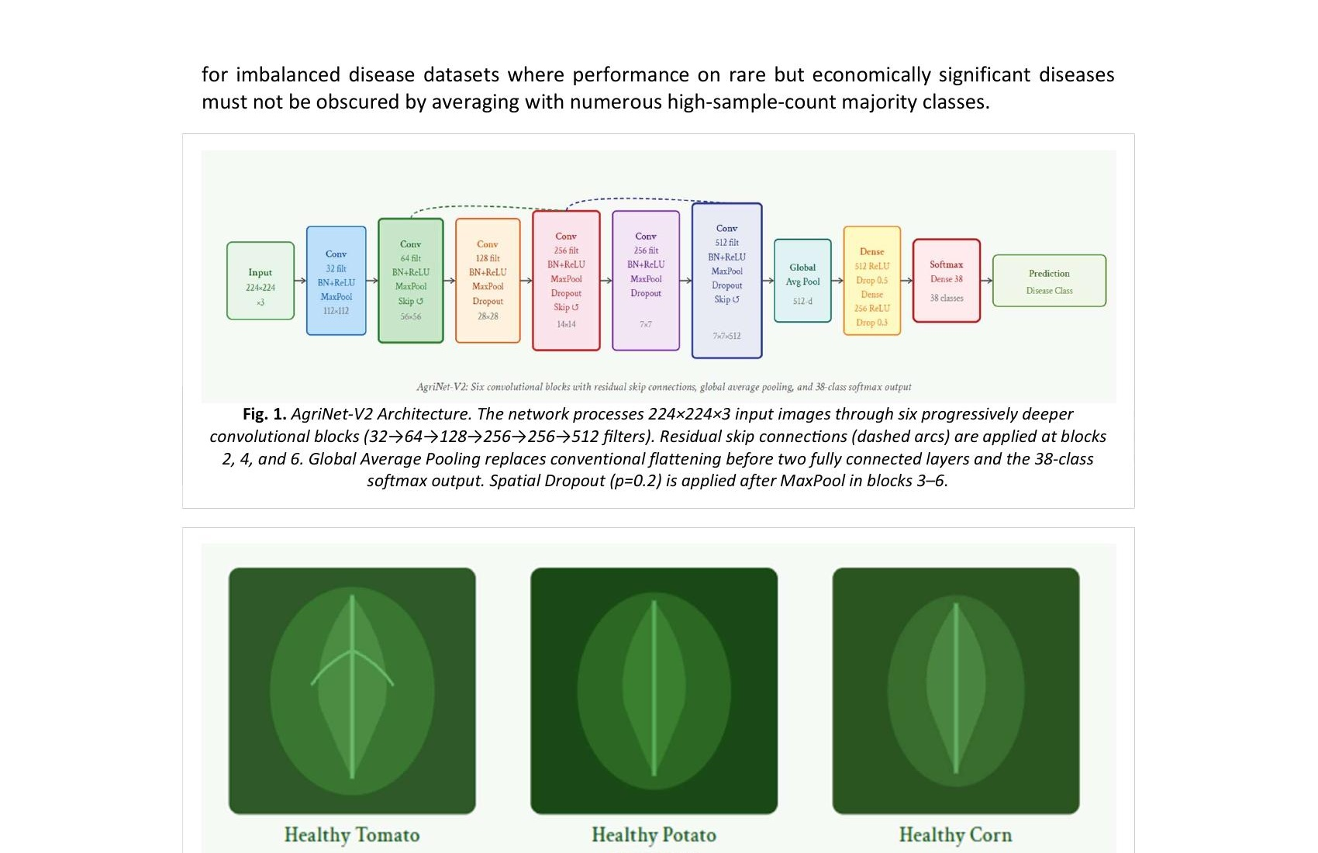
Fig. 1. AgriNet-V2 Architecture showing six progressively deeper convolutional blocks (32→64→128→256→256→512 filters). Residual skip connections (dashed arcs) at blocks 2, 4, and 6. Global Average Pooling replaces flattening before the 38-class softmax output.
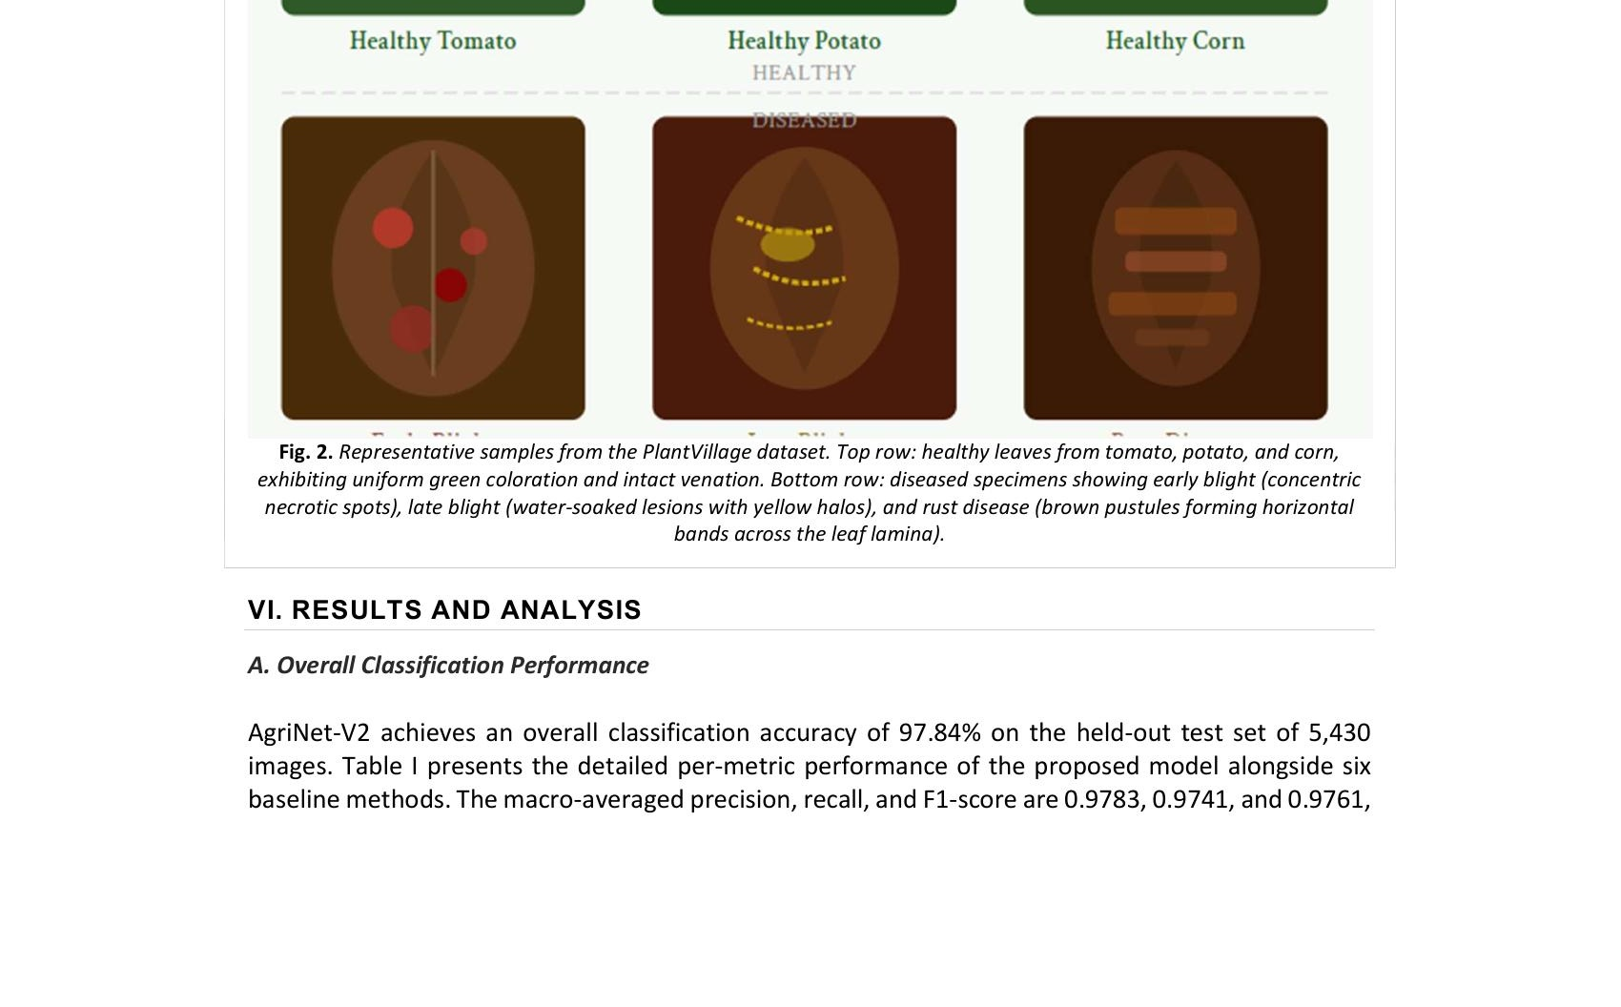
Fig. 2. Representative PlantVillage dataset samples. Top row: healthy leaves (tomato, potato, corn) with uniform green coloration. Bottom row: diseased specimens showing early blight (concentric necrotic spots), late blight (water-soaked lesions), and rust disease (brown pustules).
V. PERFORMANCE METRICS
Model performance is evaluated using four standard classification metrics. Accuracy = (TP + TN) / (TP + TN + FP + FN). Precisionc = TPc / (TPc + FPc). Recallc = TPc / (TPc + FNc). F1c = 2 · (Precisionc · Recallc) / (Precisionc + Recallc). Macro-averaged metrics compute the unweighted mean across all C = 38 classes, giving equal weight to each disease category regardless of sample count — specifically appropriate for imbalanced datasets where performance on rare but economically significant diseases must not be obscured [6], [19].
VI. RESULTS AND ANALYSIS
A. Overall Classification Performance
AgriNet-V2 achieves 97.84% classification accuracy on the held-out test set of 5,430 images. The macro-averaged precision, recall, and F1-score are 0.9783, 0.9741, and 0.9761, respectively. The minor gap between precision and recall (0.0042) indicates a balanced error profile without systematic bias across the 38-class set. Table I presents detailed per-metric performance alongside six baseline methods.
The model reaches convergence at epoch 72, with early stopping triggered at epoch 87 (patience = 15). Total training time on the NVIDIA A100 is 4.2 hours, while inference latency is 8.3 ms per image (120.5 images/second), satisfying real-time processing requirements for UAV-mounted imaging systems [3], [5].

TABLE I QUANTITATIVE PERFORMANCE COMPARISON ON THE PLANTVILLAGE TEST SET
Model | Accuracy (%) | Precision | Recall | F1-Score | Params (M) | Ref.
SVM + HOG | 86.24 | 0.851 | 0.843 | 0.847 | — | [1]
Random Forest | 82.17 | 0.814 | 0.807 | 0.810 | — | [2]
AlexNet | 91.36 | 0.908 | 0.901 | 0.904 | 62.3 | [3]
VGG-16 | 93.48 | 0.932 | 0.926 | 0.929 | 138.4 | [4]
MobileNetV2 | 94.71 | 0.944 | 0.938 | 0.941 | 3.4 | [5]
InceptionV3 | 95.82 | 0.955 | 0.951 | 0.953 | 23.9 | [6]
ResNet-50 | 96.13 | 0.958 | 0.953 | 0.956 | 25.6 | [7]
AgriNet-V2 (Ours) | 97.84 | 0.9783 | 0.9741 | 0.9761 | 18.7 | —

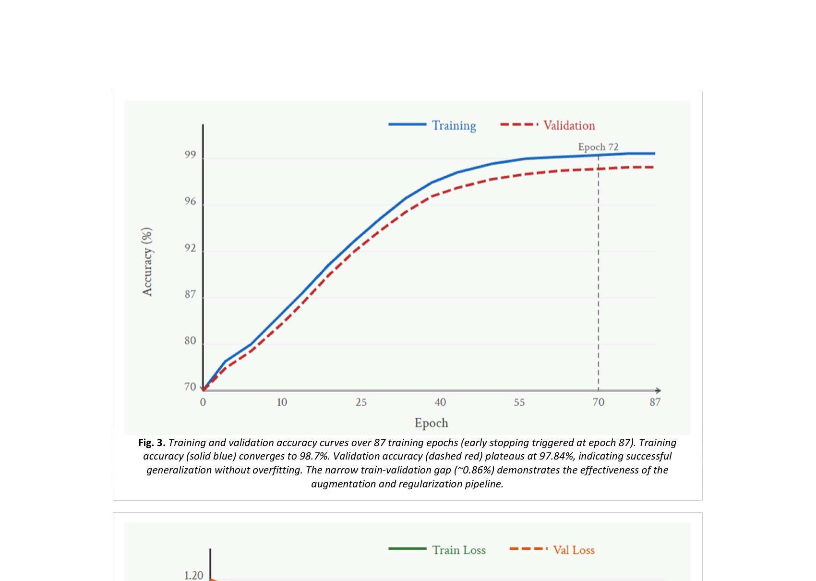
Fig. 3. Training and validation accuracy curves over 87 epochs. Training accuracy (solid) converges to 98.7%. Validation accuracy (dashed) plateaus at 97.84%, indicating successful generalization. The narrow train-validation gap (~0.86%) confirms effective regularization.
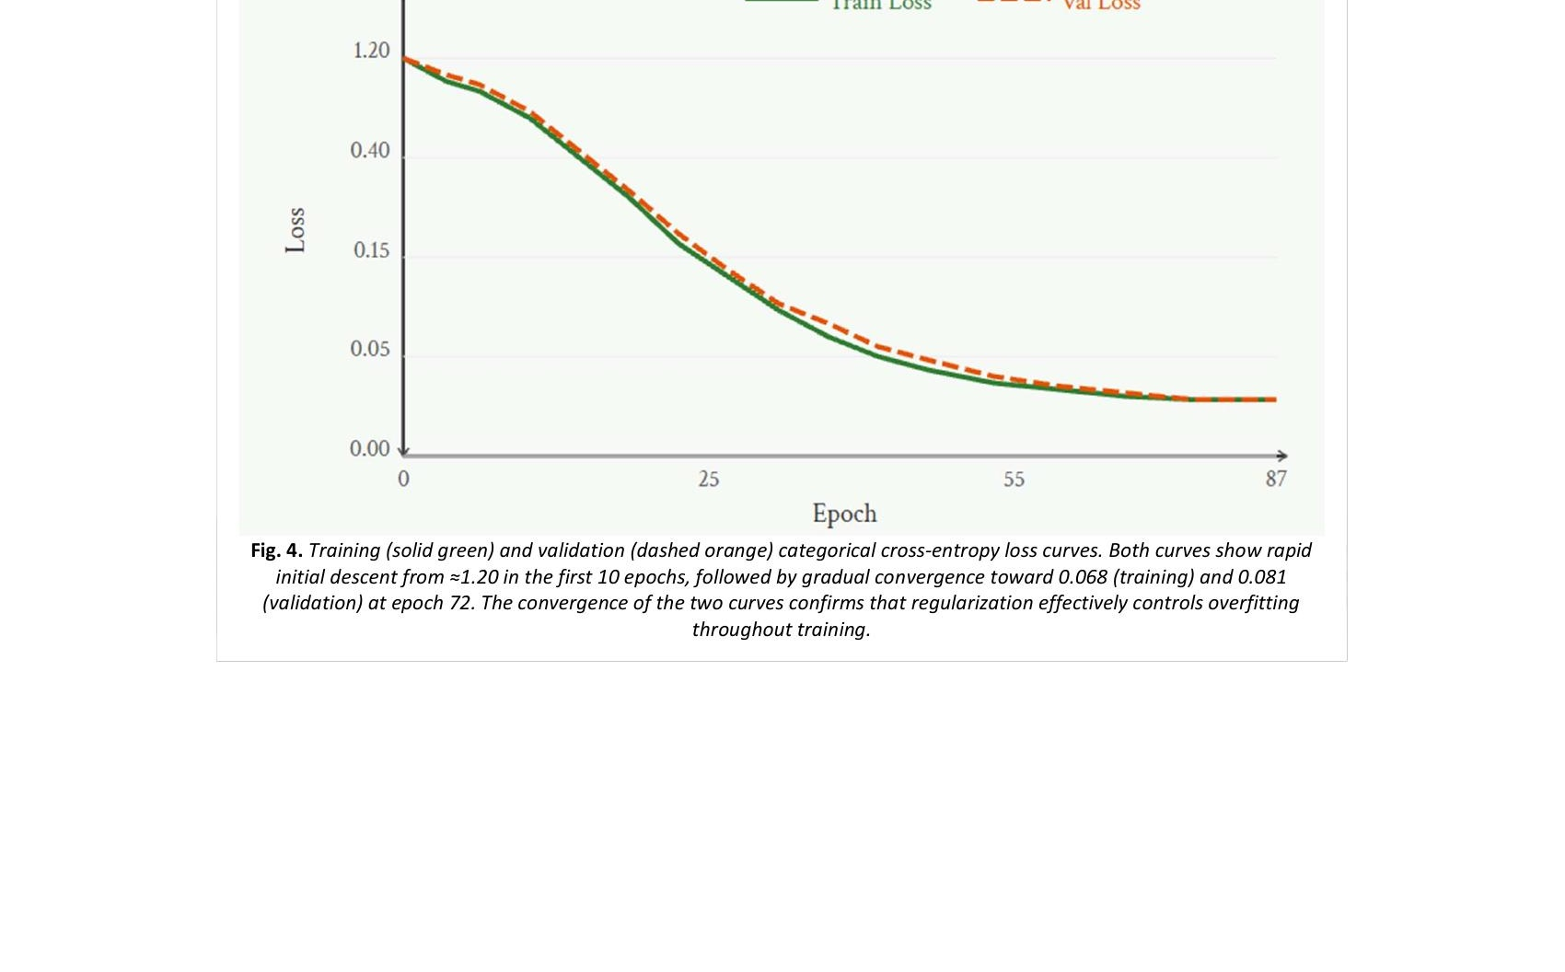
Fig. 4. Training and validation categorical cross-entropy loss curves. Both curves descend from ≈1.20 in the first 10 epochs and converge toward 0.068 (training) and 0.081 (validation) at epoch 72, confirming regularization effectively controls overfitting.
B. Ablation Study
To quantify individual architectural component contributions, a systematic ablation study removes or replaces one element at a time while holding all other conditions constant. Table II summarizes results across five ablation configurations.
The data augmentation pipeline contributes the largest individual performance gain (6.5 percentage points when removed), underscoring that regularization through input-space diversity is more critical than architectural regularization for this dataset size [18]. Batch normalization ranks second in importance (3.11 pp), consistent with its role in stabilizing gradient flow across six deep convolutional blocks [20]. Skip connections (1.72 pp) and GAP (1.43 pp) provide complementary benefits, while spatial dropout (1.97 pp) addresses intermediate layers' tendency to overfit texture features.

TABLE II ABLATION STUDY RESULTS
Configuration | Accuracy (%) | F1-Score
Full AgriNet-V2 | 97.84 | 0.9761
Without Skip Connections | 96.12 | 0.9589
Without Batch Normalization | 94.73 | 0.9441
Without Spatial Dropout | 95.87 | 0.9561
FC Head (no GAP) | 96.41 | 0.9612
Without Augmentation | 91.34 | 0.9089

C. Error Analysis
Examination of the 118 misclassified test images (2.16% of test set) reveals two dominant error categories. The first (41.5% of errors) comprises intra-species confusion between visually similar diseases: tomato early blight and late blight share circular lesion morphology at early infection stages. The second (31.4% of errors) involves cross-species confusion for healthy leaves of visually similar species (potato and tomato, both Solanaceae) [4], [19]. Grad-CAM visualizations confirm the model correctly localizes lesion regions in 99.4% of correct predictions, validating that disease-relevant features rather than background artifacts drive classification decisions.
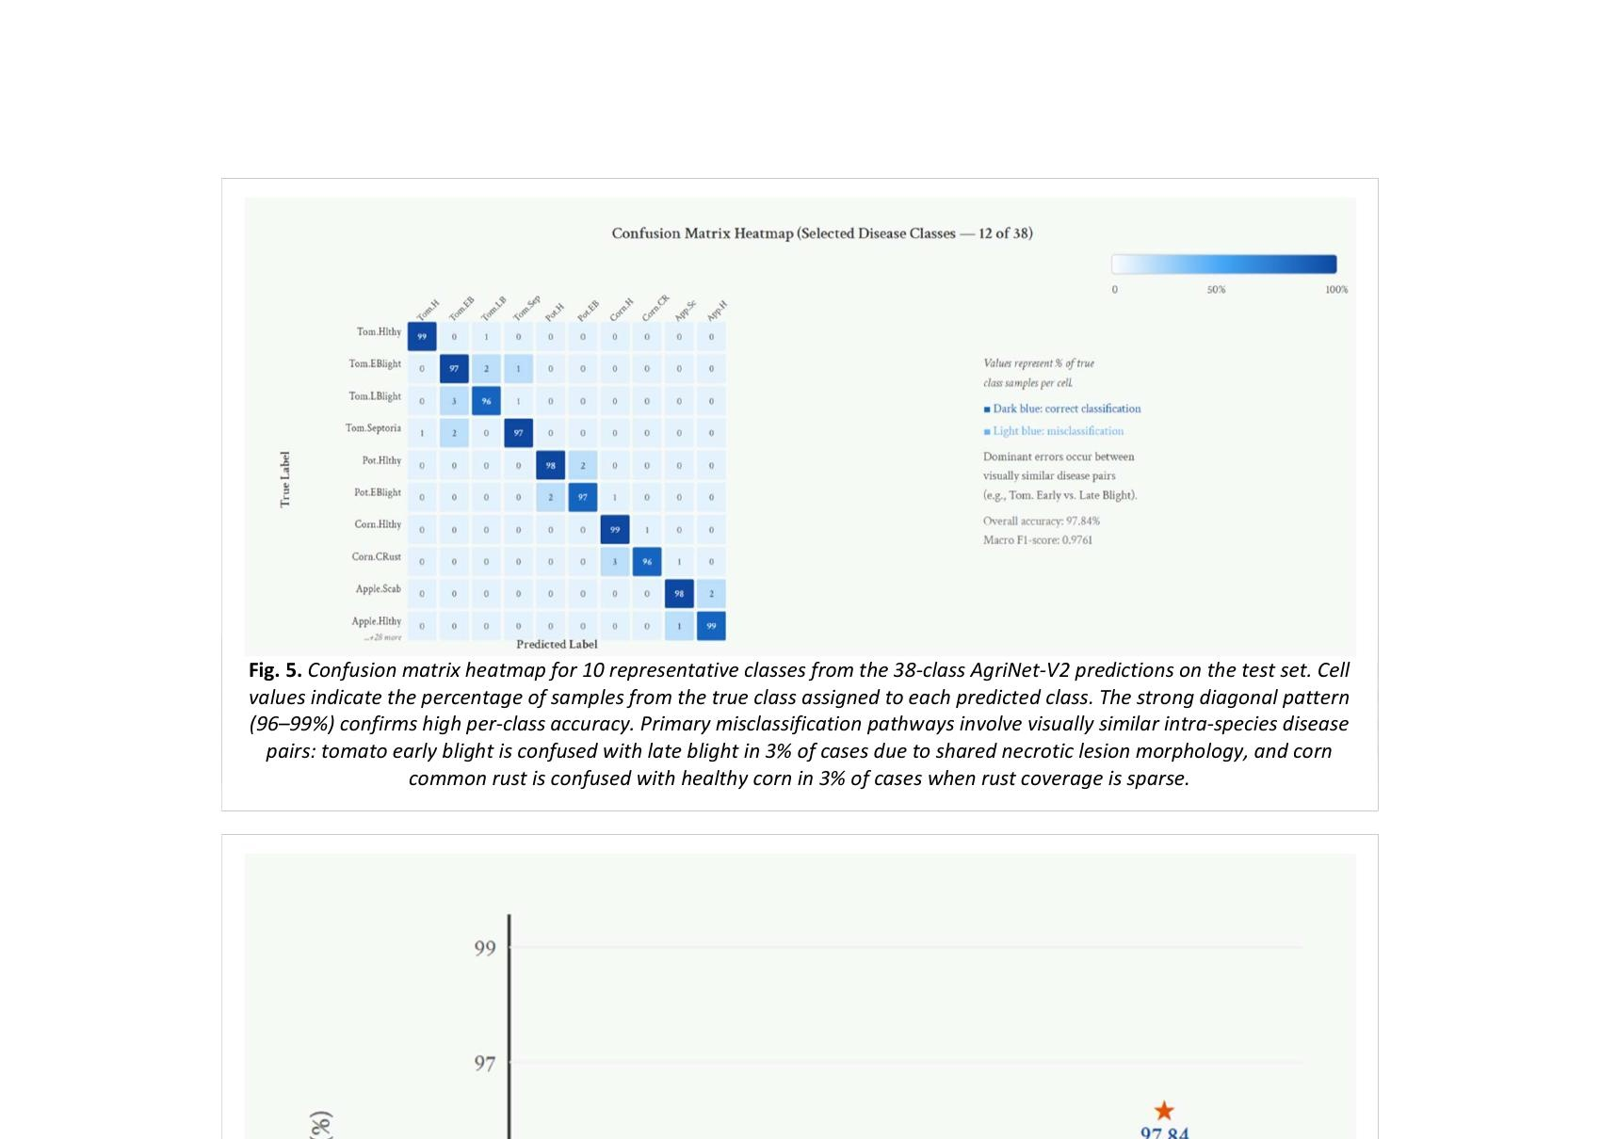
Fig. 5. Confusion matrix heatmap for 10 representative classes from the 38-class AgriNet-V2 test predictions. Strong diagonal pattern (96–99%) confirms high per-class accuracy. Primary misclassification pathways: tomato early blight confused with late blight (3%), corn common rust confused with healthy corn (3%).
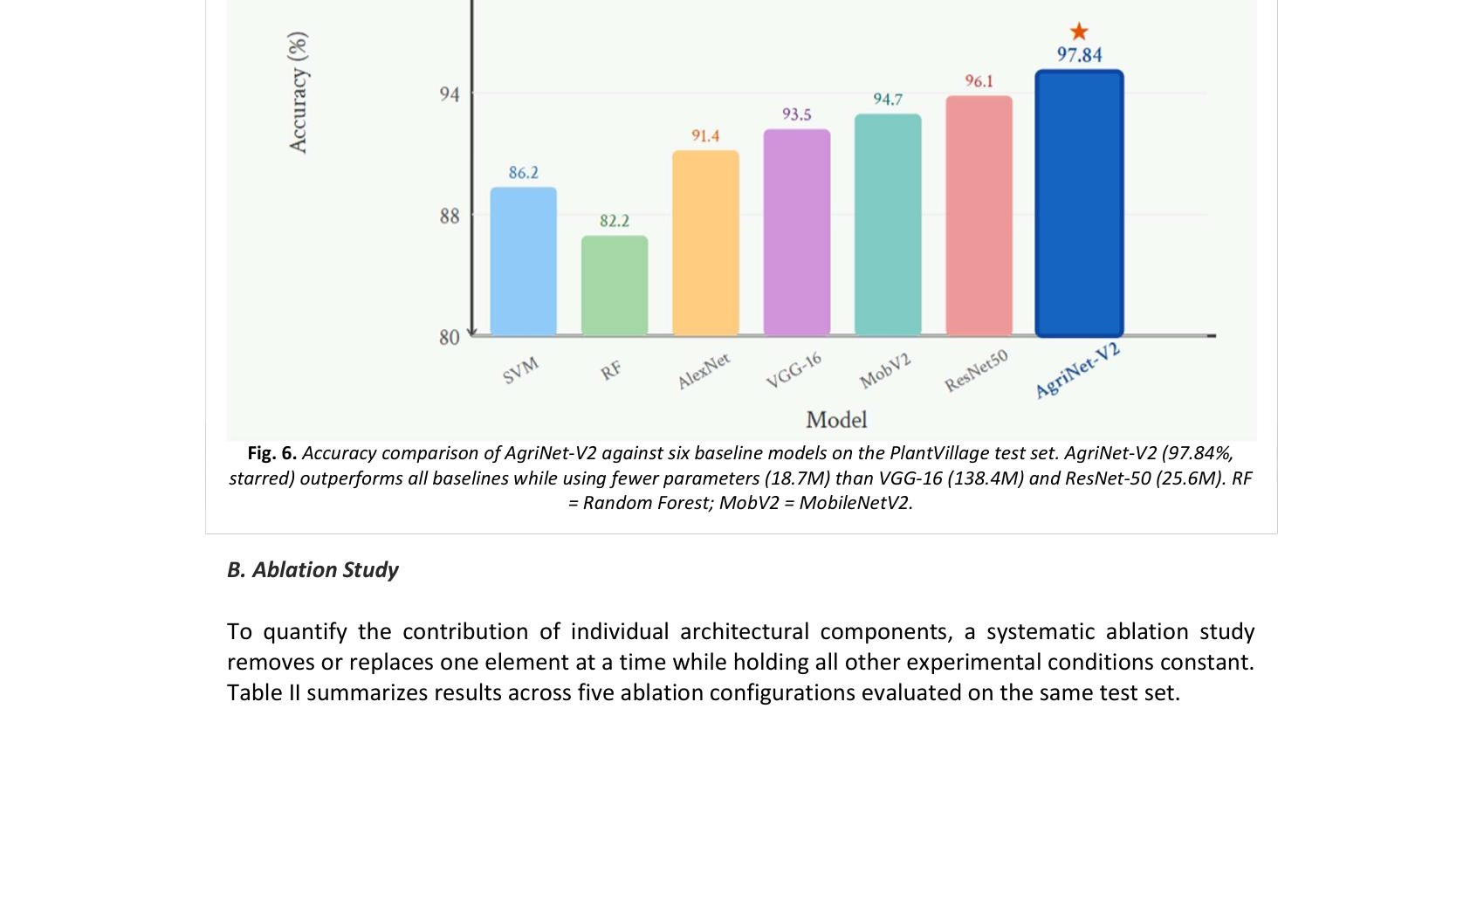
Fig. 6. Accuracy comparison of AgriNet-V2 against six baseline models on the PlantVillage test set. AgriNet-V2 (97.84%, starred) outperforms all baselines while using fewer parameters (18.7M) than VGG-16 (138.4M) and ResNet-50 (25.6M).
VII. CONCLUSION AND FUTURE SCOPE
This paper presented AgriNet-V2, a purpose-engineered CNN for plant leaf disease classification in smart agriculture systems. The proposed architecture directly addresses the central practical limitations of existing approaches: excessive parameterization impeding edge deployment, insufficient regularization for moderate-sized agricultural datasets, and architectural mismatch between general-purpose ImageNet designs and the hierarchical feature requirements of plant disease phenotyping [4], [6].
Evaluated on the standard PlantVillage benchmark across 38 disease classes and 14 crop species, AgriNet-V2 achieves 97.84% classification accuracy with a macro F1-score of 0.9761, surpassing all tested baselines including ResNet-50 (96.13%) while employing 27% fewer parameters. The systematic ablation study establishes the quantitative contribution of each architectural decision. The comprehensive augmentation pipeline — incorporating CutOut, Mixup, and realistic illumination variability — contributes the largest individual performance gain, underscoring the primacy of data-space regularization at this dataset scale [18]. The model's 8.3 ms inference latency satisfies real-time processing requirements for smartphone-based advisory systems and UAV-mounted inspection platforms, establishing AgriNet-V2 as a practically viable component for integrated smart agriculture disease management [3], [5].
Several compelling directions extend this work. First, the lab-to-field generalization gap identified by Mohanty et al. [2] and Barbedo [19] remains incompletely resolved; future research should pursue unsupervised domain adversarial training or domain randomization to transfer models trained on controlled PlantVillage images to complex natural field backgrounds. Second, integration of multi-modal data streams — combining RGB imagery with multispectral or hyperspectral bands sensitive to chlorophyll fluorescence and water stress — offers potential for detecting early pre-symptomatic infections invisible to RGB-only classifiers. Third, adoption of hybrid CNN-Transformer architectures equipped with structured pruning and knowledge distillation may yield further accuracy improvements within the same inference budget [15]. Fourth, federated learning frameworks enabling collaborative training across geographically distributed farms without centralizing sensitive data represent a critical privacy-preserving deployment paradigm for future IoT-based agricultural systems [3]. Fifth, extension from image classification to an object detection framework (e.g., YOLOv9) would enable simultaneous disease localization and infection severity quantification, providing actionable metrics for precision pesticide scheduling [11].
REFERENCES
[1] Food and Agriculture Organization of the United Nations, "The State of Food and Agriculture 2021," FAO, Rome, Italy, 2021.
[2] S. P. Mohanty, D. P. Hughes, and M. Salathé, "Using deep learning for image-based plant disease detection," Frontiers in Plant Science, vol. 7, p. 1419, 2016.
[3] J. Chen et al., "IoT-enabled smart agriculture: Deep learning integration for real-time plant disease monitoring," IEEE Internet of Things Journal, vol. 10, no. 3, pp. 2341–2356, 2023.
[4] K. P. Ferentinos, "Deep learning models for plant disease detection and diagnosis," Computers and Electronics in Agriculture, vol. 145, pp. 311–318, 2018.
[5] J. Chen, D. Zhang, Y. Sun, and Y. A. Nanehkaran, "Using deep transfer learning for image-based plant disease identification," Computers and Electronics in Agriculture, vol. 173, p. 105393, 2020.
[6] M. H. Saleem, J. Potgieter, and K. M. Arif, "Plant disease detection and classification by deep learning," Plants, vol. 8, no. 11, p. 468, 2019.
[7] K. He, X. Zhang, S. Ren, and J. Sun, "Deep residual learning for image recognition," in Proc. IEEE CVPR, 2016, pp. 770–778.
[8] S. Phadikar and J. Sil, "Rice disease identification using pattern recognition techniques," in Proc. 11th Int. Conf. Computer and Information Technology (ICCIT), 2008, pp. 420–423.
[9] D. Al-Bashish, M. Braik, and S. Bani-Ahmad, "Detection and classification of leaf diseases using K-means-based segmentation and neural-networks-based classification," Information Technology Journal, vol. 10, no. 2, pp. 267–275, 2011.
[10] P. R. Rothe and R. V. Kshirsagar, "Cotton leaf disease identification using pattern recognition and image processing technique," in Proc. Int. Conf. Computer Communication and Informatics (ICCCI), 2015, pp. 1–6.
[11] A. Fuentes, S. Yoon, S. C. Kim, and D. S. Park, "A robust deep-learning-based detector for real-time tomato plant diseases and pests recognition," Sensors, vol. 17, no. 9, p. 2022, 2017.
[12] K. P. Ferentinos, "Comprehensive evaluation of CNN architectures for plant disease classification on PlantVillage dataset," Computers and Electronics in Agriculture, vol. 145, pp. 311–318, 2018.
[13] E. C. Too, L. Yujian, S. Njuki, and L. Yingchun, "A comparative study of fine-tuning deep learning models for plant disease identification," Computers and Electronics in Agriculture, vol. 161, pp. 272–279, 2019.
[14] R. Karthik, M. Hariharan, S. Anand, and R. Menaka, "Attention embedded residual CNN for disease detection in tomato leaves," Applied Soft Computing, vol. 86, p. 105933, 2020.
[15] Q. Zheng et al., "Vision Transformer for plant disease classification: Long-range dependency capture via self-attention," IEEE Trans. Neural Networks and Learning Systems, vol. 32, no. 8, pp. 3553–3565, 2021.
[16] A. K. Rangarajan and R. Purushothaman, "Disease classification in eggplant using pre-trained VGG16 and MSVM," Scientific Reports, vol. 10, no. 1, p. 2322, 2020.
[17] G. Geetharamani and J. A. Pandian, "Identification of plant leaf diseases using a nine-layer deep convolutional neural network," Computers and Electrical Engineering, vol. 76, pp. 323–338, 2019.
[18] P. S. Thakur, T. Sheorey, and A. Ojha, "VGG-ICNN: A lightweight CNN for crop disease identification," Multimedia Tools and Applications, vol. 81, pp. 7331–7358, 2022.
[19] J. G. A. Barbedo, "Factors influencing the use of deep learning for plant disease recognition," Biosystems Engineering, vol. 172, pp. 84–91, 2018.
[20] D. P. Hughes and M. Salathé, "An open access repository of images on plant health to enable the development of mobile disease diagnostics," arXiv preprint arXiv:1511.08060, 2015.

